Use-Case Realization Report
DeleteCustomer

Issue <1.0>
Revision History
Date | Issue | Description | Author
<dd/mmm/yy> | <x.x> | <details> | <name>

Table of Contents
1. Brief Description 4
2. Flow of Events 4
3. Interaction Diagrams 4
3.1 Collaboration Diagram for Delete Customer 4
3.2 Sequence Diagram for Delete Customer 5
4. Participating Objects 7
5. Class Diagrams 7
5.1 Class Diagram for Delete Customer 7
6. Derived Requirements 7

Use-Case Realization Report
DeleteCustomer

Brief Description

Flow of Events
[enter the flow of events here; you can use subsections to structure the text]

Interaction Diagrams

Collaboration Diagram for Delete Customer
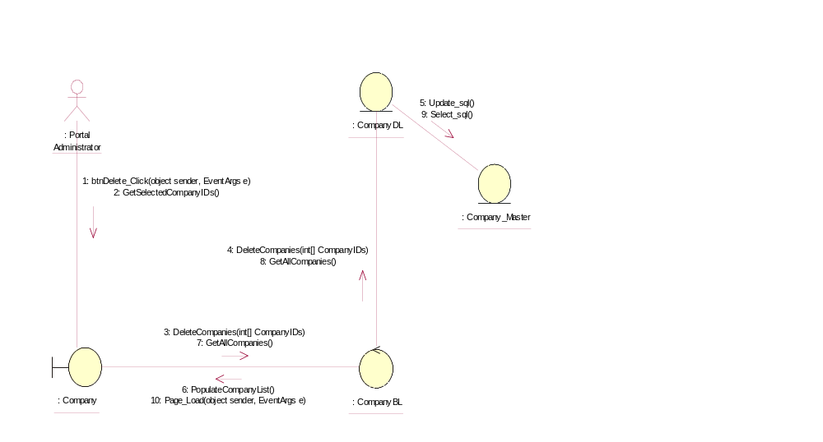

Sequence Diagram for Delete Customer
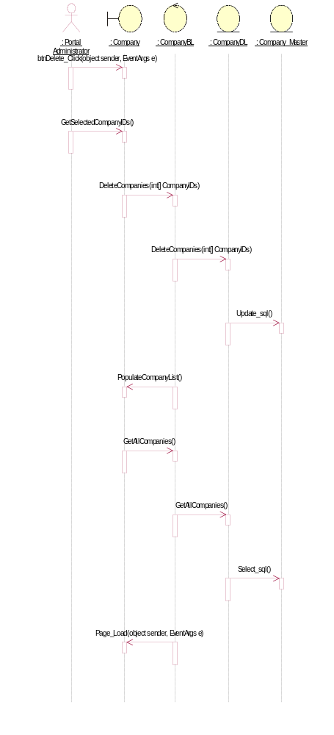

Participating Objects
: Company

: Company_Master

: CompanyBL

: CompanyDL

: Portal Administrator

Class Diagrams

Class Diagram for Delete Customer
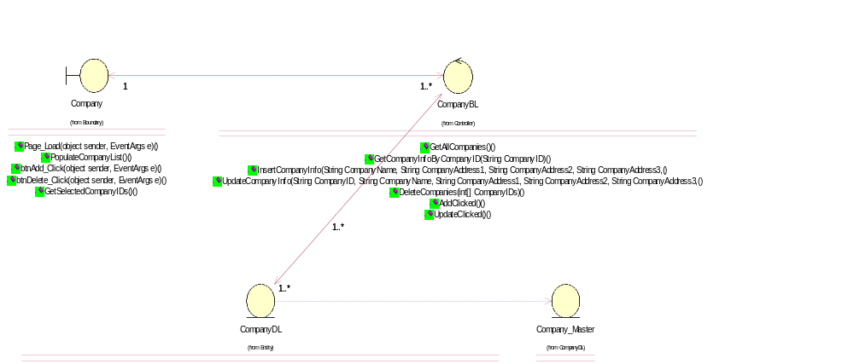

Derived Requirements
[enter the derived requirements here]

